HOMER MAXWELL BETTY JENNINGS

1763 – 1812 c. 1770 - 1833

Homer or Omer was born in Dumfries, Scotland the son of William, a labourer, and Agnes Maxwell. He was baptised in Dumfries on 8 May 1763 and died on 5 December 1812 age 48. There is no record of why or how Homer migrated to the Lancashire/Yorkshire area although it appears several his siblings also “emigrated” to Haslingden. It is clear that “our’ Homer is connected to Scotland: as his age at death (48) matches his date of birth and there are no other potential birth/baptism records for a Homer Maxwell other than “our” Homer. Betty was the daughter of William, a weaver, and Betty Jennings. She was baptised on 29 May 1794 in Sowerby, and died on 9 May 1833, age 63. Both were buried at the Ebenezer Baptist Church (see photo) in Hebden Bridge.

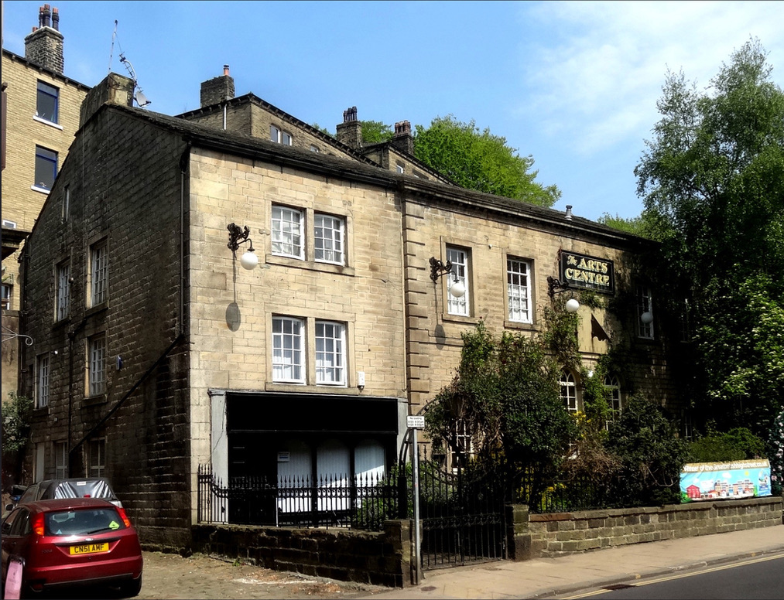

Marriage

The next and reliable record we have for Homer is his marriage by license at 27 years old to Betty Jennings on 3 January 1791 at St. John the Baptist Church, Halifax, Yorkshire. Homer was 28 and of the parish of Whalley and a linen draper. Betty was of the parish of Sowerby. Her age is a little unclear. Betty was 63 at the time of her death in 1833 which would make her year of birth 1770 and thus her age on marriage would be 21. However, the most likely record of Betty Jennings is a baptism record although this shows she was baptised on 29 May 1774 in Sowerby. Possibly she was baptised some years after her birth.

Homer and Betty had 11 children:

- William Maxwell born 28 December 1791 in Haslingden, baptised 7 January 1792
- Agy (Agnes?) Maxwell born 16 June 1793 in Haslingden, baptised 24 June 1793
- Betty Maxwell born 25 February 1795 in Hebden Bridge, baptised 10 March 1795
- Mary Maxwell born 9 December 1796 in Hebden Bridge, baptised 1 January 1797
- Thomas Maxwell (our grandfather*3) born 3 December 1798 in Sowerby, baptised 2 January 1801
- Hannah Maxwell born 20 December 1800 in Sowerby, baptised also on 2 January 1801 with her brother Thomas
- Homer Maxwell born 1803 in Sowerby
- Gilmore Maxwell born 22 March 1805 in Sowerby, baptised 27 April 1805
- Martha Maxwell born 13 March 1807 in Sowerby, baptised 11 April 1807
- John Maxwell born 24 June 1809 in Sowerby, baptised 7 July 1809
- Robert Maxwell born 3 December 1811 in Hebden Bridge, baptised 23 January 1812

All their children are recorded in the Baptism records of the Ebenezer Particular Baptist church, Bacup, the relevant document references being shown in the footnotes. These references refer to the archival records held of non-conformist churches and can be accessed via the [UK] National Archives and/or genealogy sites. All their children apart from John and Robert were baptised at the Bacup Baptist Church by John Hirst who had been appointed pastor of the Church in 1773. Robert was baptised by the Reverend John Fawcett who was appointed in 1777 pastor of the Ebenezer Baptist Church in Hepton Bridge where Homer and Betty were buried. John was baptised by H. Maxwell, presumably his father and probably at the Baptist Church in Hepton Bridge. Homer and Betty may have moved to the Baptist Church at Hepton Bridge by the time of John’s birth because by 1810 the congregation at Bacup was so large that they had to build a new chapel, completed in 1812. It may also be that Hepton Bridge was a more convenient location.

The Baptist church in Bacup originated in 1710 and the picture below shows how the church looked in 1812 and later in the late 19th century when it was enlarged to meet the larger congregation. More information about the Bacup Baptist Church is available at:

http://rossendale-fhhs.org.uk/files/bacup_churches/church_218.html

I suspect that Homer and Betty first met at the Baptist church. The Particular Baptists believed that Christ died only for an Elect and thus followed a strong Calvinist approach. I am not sure what Homer and Betty would have made of their children later becoming members of the Church of England although they may have recognised the need in that age to be part of the established church to “get on”.

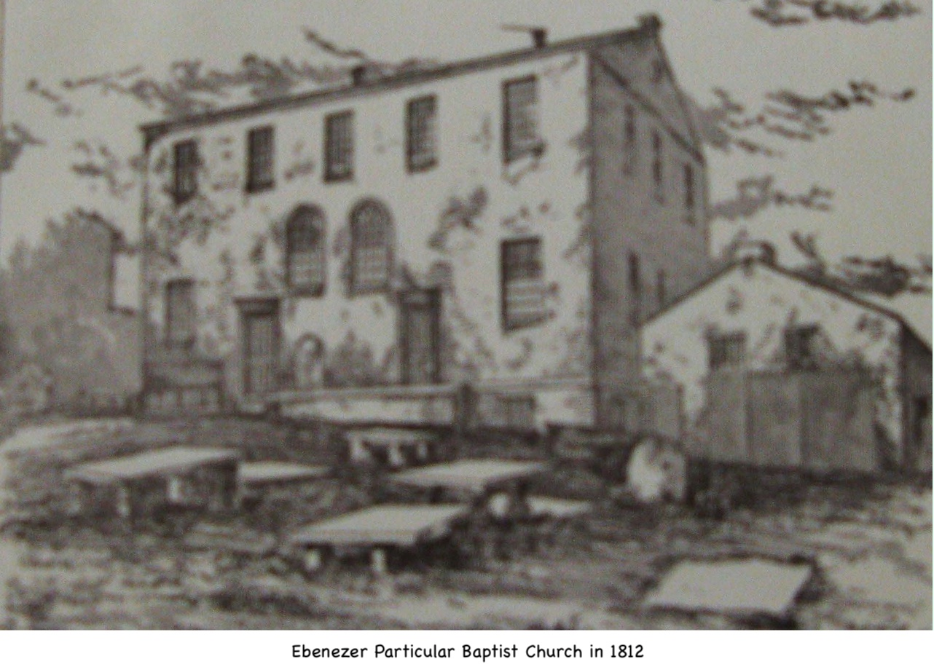
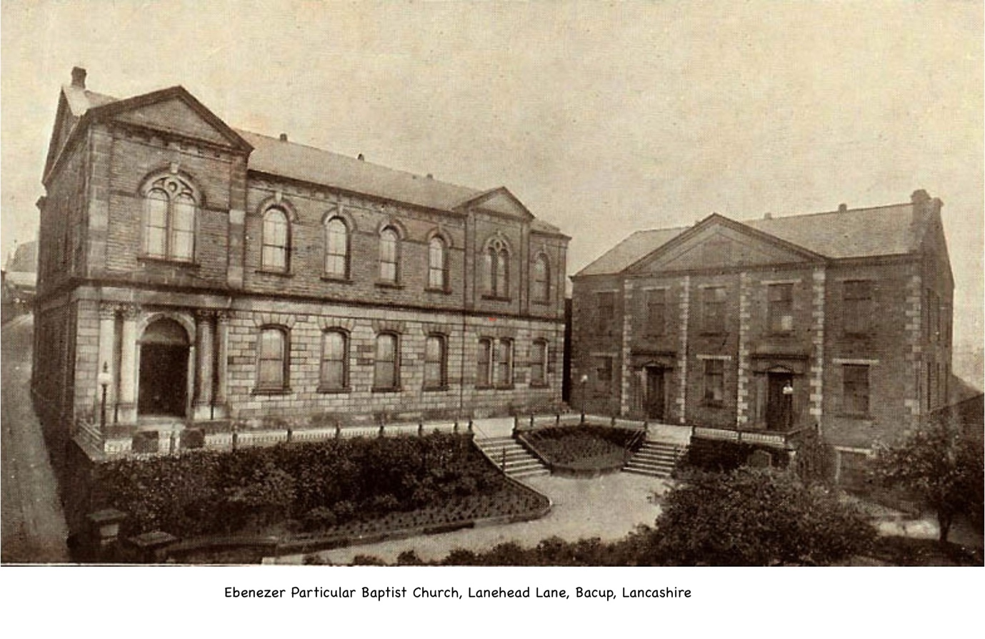
Occupation

Their marriage record states that Homer was of the parish of Whalley and a linen draper. The ancient parish of Whalley included Haslingden which is where our line of Maxwells congregated in the early 1800s. As a linen draper, Homer could either have sold linen as a retailer, but he was more likely the middleman between the wholesale linen buyers and the retail outlets, with the Sowerby area as his “territory”. The Family Search website states that “Drapers, or linen drapers, used to be the supervisors of the makers of woollen and other types of cloth since only they were allowed to buy from the manufacturers or to import it [from Ireland]. The wholesale draper (or dealer) would buy imported cloths from the merchants, and also British-produced goods from manufacturers in, say Manchester or Paisley. He acted as the middleman by reselling these to the retail linen drapers throughout his chosen territory in Britain, through his travellers (travelling salesmen)”. Being a linen draper may explain how Homer moved to the north of England: it was the time of the industrial revolution and the mills there would have been a good source for business. Dumfries was also a wool producing town/area and there is a record of a Homer Maxwell being a merchant of Dumfries, although research shows that he is not a direct relative.

There are two records of apprenticeship indentures in the West Yorkshire Archives service which show a Homer Maxwell of Sowerby as the Master. One is dated 16 June 1798 and the other 10 September 1801. Both relate to “a poor child”. There will be more detail when I can examine these records.

Where did they live

Homer and Betty lived for the most part in Sowerby and in later years in Heptonstall as shown by the Land Tax records for West Yorkshire 1799-1813. From their children’s baptism records, they seem to have first lived in Haslingden, then Hebden Bridge (maybe with her parents as that was her home) before living in Sowerby and later Heptonstall where he died.

Occupier | Land Owner | Year | Residence | Division
Homer Maxwell | Sir Watts Horton | 1799 | Sowerby | Morley
Homer Maxwell | Sir Watts Horton | 1800 | Sowerby | Morley
Homer Maxwell | Sir Watts Horton | 1801 | Sowerby | Morley
Homer Maxwell | Sir Watts Horton | 1802 | Sowerby | Morley
Homer Maxwell | Sir Watts Horton | 1803 | Sowerby | Morley
Homer Maxwell | Sir Watts Horton | 1804 | Sowerby | Morley
Homer Maxwell | Sir Watts Horton | 1805 | Sowerby | Morley
Homer Maxwell | Sir Watts Horton | 1806 | Sowerby | Morley
Homer Maxwell | Sir Watts Horton | 1807 | Sowerby | Morley
Homer Maxwell | Sir Watts Morton | 1808 | Sowerby | Morley
Homer Maxwell | Sir Watts Horton | 1809 | Sowerby | Morley
Homer Maxwell | Wm Patchett | 1810 | Heptonstall | Morley
Homer Maxwell | Wm Patchett | 1811 | Heptonstall | Morley
Homer Maxwell | Wm Patchett | 1812 | Heptonstall | Morley
Homer Maxwell | Wm Patchett | 1813 | Heptonstall | Morley

The entry for 1810 refers to the occupant being “in right of his wife, Homer Maxwell” whereas the entry for 1813 states “in rights of his wife late Homer Maxwell”. which give us an indication of when he died and cross-references his gravestone detail. I can find no record of a Will for Homer but there is a Death Duty record dated 1834 for a Betty Maxwell who resided in Haslingden. The Death Duty record shows Thomas Maxwell as the administrator and resident in Haslingden. How Betty managed after Homer’s death with a large young family is unclear but maybe William, the eldest son, would have been the breadwinner by then: he would have been 19 and a private in the Royal House Guards (see section on William at the end of this biography). The Land Tax due on the property at Sowerby throughout 1799-1809 was £1 7 shillings and 7 pence. This was a high tax value compared to the other properties that Sir Watts Holden held, whereas the Land tax for the property at Heptonstall 1810-1813 was 4 shillings and 4 ¾ pence. If the Death Duty Record referred to above is “our” Betty Maxwell, she left under £100. £100 is worth about £13,000 today (2020). Maybe Homer fell on hard times or became ill or injured which meant that they needed to move to a cheaper property in 1810. It is interesting that on the move to Heptonstall, the right to occupy is given to Betty so perhaps Homer was trying to ensure that Betty was secure in the tenancy after his death, but I cannot find any Land tax records after 1813 with her as tenant. Perhaps she moved to Haslingden where Homer’s siblings were living.

Overall, Homer and Betty appear to have been good tenants given the “permanency” of their tenancy in Sowerby and later Heptonstall. Their landlord for most of this period was Sir Watts Horton (1753-1811) who was the second Baronet Chadderton and Sheriff of Lancashire, the family home being Chadderton Hall near Oldham. He owned land around Broadstones Halifax and the Corn Market although he sold much to pay for the upkeep of Chadderton Hall and his lavish lifestyle. This may explain the change of landlord in 1810 to William Patchett. An Abraham Hollinrake, who owned Lob Mill (cotton manufacturing) and had an interest in Bankfoot Mill near Hebden Bridge, which is close to Heptonstall, appears to have co-owned the property in 1812 and 1813.

Betty Jennings

There is very little information about Betty apart from her baptism, marriage and death. However, the Bothwick Institute for Archives at the University of York provided me a copy of her Probate. She died intestate and the document is interesting as it gives information about her children. What is more interesting is that Thomas seems to be firmly in the seat as head of the family, despite his elder brother William, as he is appointed administrator for Betty’s estate and the other children renounced any claim to her estate. The “sign off” of the administration states that Betty died on 9 May 1833, with the estate being wound up on 22 April 1834, the estate being valued under £100 (£c.13,000 in 2020). There is also a record from the Probate Index, and Index of Death Duty Register.
There is a record held at the West Yorkshire Archives (Calderdale) showing the inscriptions on Homer and Betty’s tombstones from the Ebenezer Baptist Church graveyard in Hebden Bridge. This record includes the tombstones for both Betty and Homer which I have yet to see but the online reference gives their inscriptions, which read: “Here lieth the Body of Homer Maxwell who died Decr [December] 5th 1812 Aged 48 Also Betty, the wife of Homer Maxwell who died May 10th 1833 Aged 63 Years”.
Homer’s and Betty’s Children

William Maxwell born 28 December 1791 in Haslingden.

William was the eldest son of Homer and Betty. He joined the Royal Horse Guards on 30 October 1812. According to his discharge papers, he served at San Sebastian in Spain (1814) and at the Paris Camp, Waterloo (1815). Although the Royal Horse Guards were involved at the battle of Waterloo, it is unclear if William was involved in the battle itself. According to the National Army museum website section on The Royal Horse Guards, they charged with the Household Brigade at Waterloo, before joining the occupation forces in France until 1816.

William was discharged from the Royal Horse Guards on 30 December 1816 after serving 4 years and 43 days. He then joined the 1st Foot Grenadier Guards on 28 January 1817 from which he was discharged 18 years and 276 days later on 30 October 1835 on medical grounds. He is recorded as having further service of 11 days from 31 October 1835 to 10 November 1835, making total service of 22 years and 330 days. William had been suffering from rheumatism for the previous 12 months, which resulted in him being unfit for military duties. His record shows his trade as a weaver. The discharge papers also give his age, 42; his height (5' 9"); colour of eyes (grey); hair (brown), and that he was of pale complexion. It is also recorded that “his character is good”.

Betty’s Administration refers to William Maxwell of London in the County of Middlesex, Private soldier of the first foot Grenadier Guards. His sealed signature on the renunciation document is similar to that on his discharge papers from the Grenadier Guards.

Apart from the above, there is little further information about William and so far I can find no record of his death.

Agy (Agnes?) Maxwell born 16 June 1793 in Haslingden

There is no mention of Agy/Agnes in the Administration document which suggests that she had died beforehand. I have found a record of an Agnes Maxwell who died in 9 November 1863 and is buried at Haslingden but this makes no sense as she is not mentioned in the Administration.

Betty Maxwell born 25 February 1795 in Hebden Bridge

We know from her mother’s Administration that she married John Wade of Hebden Bridge at St. John the Baptist Church in Halifax on 27 April 1819. John Wade is shown as a manufacturer on the marriage banns and we know from the Administration that he was a worsted manufacturer. They lived in Machpelah near Hebden Bridge. John and Betty had 8 children with John dying before the 1861 census. Betty died in 1878 in Bradford, Yorkshire.

This link gives some family background to the Wade family. It does not name Betty directly but the Administration gives proof of their marriage.

http://www.mallandain.com/rf.wade.htm

Mary Maxwell born 9 December 1796 in Hebden Bridge

The Administration tells us that Mary married James Maxwell, and I think that this must be James Hincliffe Maxwell. They were married on 3 April 1815 at St. James Church in Haslingden. At the time of the Administration, James and Mary were in the U.S. James Hincliffe was the son of George Maxwell who could have been an older brother of Homer Maxwell.

James and Mary had two children and lived in Pennsylvania, USA.

Thomas Maxwell born 3 December 1798 in Sowerby

Thomas’ biography is written separately as he is our great*3 grandfather.

Hannah Maxwell born 20 December 1800 in Sowerby

Hannah is described as a spinster on the Administration but she married a Richard Hargreaves at St. Mary the Virgin, Bury on 16 October 1834. Richard was a plumber and glazier like her brother Thomas and this is probably how they met. Richard Hargreaves was witness to the administration of Betty Maxwell's estate. Their marriage was witnessed by Benjamin Hincliffe Maxwell & Homer Maxwell (possibly her younger brother?). At time of writing, I am unable to find Hannah and Richard in any census.

Homer Maxwell born 1803 in Sowerby

This is interesting as until I was able to get a copy of Betty’s Administration I could find no evidence of Homer but at the same time I was puzzled that there was no son called Homer, after his father (and grandfather on his father’s mother’s side). The Administration refers to Homer of Haslingden, plumber and glazier. On the 1841 census, he was described as an engineer and in later trade directories of the time as a plumber, glazier and gas fitter.

On 30 September 1822 he married Millicent Duckworth, the sister of Dinah Duckworth who had married his brother, Thomas. Unhappily, Millicent died in July 1830 and on 4 April 1834 he re-married, Elizabeth Jane Cowpe with whom he had 8 children.

Homer and Millicent had 3 children, Elizabeth, Thomas and Jane. Elizabeth was born in 1823. She married Jacob Ollerenshaw on 28 March 1849 but unfortunately she died in 1861. Jacob subsequently re-married Alice Maxwell, the widow of Henry Maxwell, the son of his brother Thomas. Henry would have been Homer’s nephew. Thomas was born in 1827 and sadly died in 1838, age 11. Jane was born in 1830 and died in 1857 age 27.

Gilmore Maxwell born 22 March 1805 in Sowerby

The Administration states that Gilmore was in the U.S. possibly with his sister Mary and her husband James.

Martha Maxwell born 13 March 1807

In 1834 Martha was the wife of James Kenyon, a farmer of Bank Lane near Bury, Lancashire. There is a record of the marriage of James Kenyon and Martha Maxwell on 31 October 1831 at St. Mary the Virgin, Bury, the same church that her sister Hannah was married. James’ occupation is given as Carter so by the time of Betty’s administration he had become a farmer.

John Maxwell born 24 June 1809 in Sowerby

John was living in Rockingstone near Huddersfield in 1834, earning a living as a labourer.

Robert Maxwell born 3 December 1811 in Hebden Bridge

Robert was living in Bolton in 1834 and according to the Administration was a baker.

Robin Maxwell
19 September 2020
Updated 22 December 2020
Updated 8 January 2021
Updated 21 August 2021

Note
References to Folders in the footnotes refer to folders held on my computer.

Confirmed from research by genealogist, Gavin Maxwell, at ScottishIndexes.com, who also provided references to a variety of records that have helped in composing this bio.
See Folder 1763_1812_Homer_Maxwell and document: Baptism_1763_05_08_Homer Maxwell_@_Dumfries
Homer’s death date is based on the transcription of his and Betty’s grave, the record of the transcription is within the archive records of the West Yorkshire Archive service. Catalogue Finding Number TS/EB:22 from the Calderdale Tombstones Schedules (CC00122) held in Calderdale, West Yorkshire Archive Service. Betty’s item number is 66 and Homer’s 67.
The Church was built in 1777 by Dr. John Fawcett. In 1786 work began on a Sunday school: it was one of the first Baptist Sunday schools in the country. The Church became the Sunday school after the congregation moved in 1858 to the Hope Baptist Church as that church was big enough to hold all the congregation. The original Church is now the Hebden Bridge Arts Centre.
© Malcolm Bull
At this time and until 1837 marriages had to take place in a parish church and for non-conformists like Homer and Betty, it could only be by license. See Folder 1763_1812_Homer_Maxwell and documents: Marriage_1791_01_03_Banns_Homer-Maxwell_Betty_Jennings: Marriage_1791_01_03_Homer-Maxwell_Betty_Jennings_GBPRS_YORKSHIRE_007588418_00988: Marriage_1791_01_03_Transcription_Homer-Maxwell_Betty_Jennings
RG4/1731/13
RG4/1731/17
RG4/1731/21
RG4/1731/25
RG4/1731/33
RG4/1731/33
I can find no record of Homer’s birth or baptism, but Betty’s Administration clearly refers to Homer as one of her sons. The 1841 census shows a Homer Maxwell as a neighbour of [his brother] Thomas, then age 40. He is shown as an engineer, age 38 which matches his date of birth.
RG4/1731/43
RG4/1731/48
RG4/1433/14
RG4/1731/60
© Lancashire Online Parish Clerks
© Malcolm Bull
By Gavin Maxwell of Scottishindexes.com
West Yorkshire Archive Service - Catalogue SPL: 108/600 and SPL: 108/654
See Folder: 1763_1812_Homer_Maxwell – documents: Tax_Land_ 1799_ Homer_ Maxwell_@_Sowerby and similar documents for all years 1799 to 1812
In this record and for the remaining Land Tax records, the entry refers to the occupier being the wife of the Homer Maxwell. The record for 1813 refers to the “late’ Homer Maxwell
See Folder: 1763_1812_Homer_Maxwell – document: Probate_Will_1834_04_Betty_Maxwell_Haslingden_BIA17186182_Admon
Probate_Index_1834-04_ Betty_Maxwell_Widow_Homer_Maxwell
Tax_DeathDutyRegister_1834 Betty_Maxwell_BMD_IR27_116_081
Catalogue Finding Number TS/EB:22 from the Calderdale Tombstones Schedules (CC00122) held at the Calderdale office of the West Yorkshire Archive Service. Betty’s item number is 66 and Homer’s 67. See also Folder: 1763_1812_Homer_Maxwell and document: Grave_Transcription_Yorkshire_Monumental_Inscriptions_findmypast.co.uk
See Folder: 1791_William_Maxwell_S_1763_1812_Homer, and document: Military_1835_Discharge_Grenadier_Guards_Wm_Maxwell

